70th Anniversary Celebration Worship
Advent Lutheran Church
17th Sunday after Pentecost
Sunday, September 15, 2024

PRELUDE Advent Handbells: “Now Thank We All Our God” from J. S. Bach’s Cantata No. 79 (arr. Alinda B. Couper)
Gathering
The Holy Spirit calls us together as the people of God.

Confession and Forgiveness
Blessed be the holy Trinity, ☩ one God, who forgives all our sin,
whose mercy endures forever.
Amen.
Let us confess our sin and come to God for healing.
Silence for reflection.
Gracious God,
have mercy on us.
We confess that we have honored you with our lips but have harmed our neighbors with our tongues.
The cravings at war within us cause conflicts and disputes.
In our desire to be first we make distinctions among ourselves.
We place the needs of the poor and the suffering last.
In your great mercy, forgive us our sins.
Draw near to us with grace in time of need, and turn us to follow in the way of Jesus Christ, our Savior and Lord.
Amen.

God promises to forgive our iniquity and to remember our sin no more. By grace you have been saved. In the name of ☩ Jesus Christ,
the source of eternal healing, your sins are forgiven.
Amen.

Gathering Song The Church's One Foundation (ELW 654 )
This hymn was the first hymn sung at Advent’s Organization Sunday on April 11, 1954 and again later that year when Pastor Nelson was ordained on Sept. 19, 1954.

Greeting
The grace of our Lord Jesus Christ, the love of God, and the communion of the Holy Spirit be with you all.
And also with you.

Prayer of the Day
Let us pray together,
O God, you have promised through your Son to be with your church forever. We give you thanks for those who founded this community of believers and for the signs of your presence in our congregation. Increase in us the spirit of faith and love, and make our fellowship an example to all believers and to all nations. We pray through Jesus Christ, our Savior and Lord, who lives and reigns with you and the Holy Spirit, one God, now and forever.
Amen.

Word
God speaks to us in scripture reading, preaching, and song.
CHILDREN’S SERMON
Following the children’s sermon, 3-year-olds through those in fifth grade are invited to attend Sunday School and will return to worship before Holy Communion.

First Reading: Isaiah 50:4-9a
A reading from Isaiah.
⁴The Lord God has given me the tongue of a teacher,
that I may know how to sustain the weary with a word.
Morning by morning he wakens—wakens my ear
to listen as those who are taught.
⁵The Lord God has opened my ear, and I was not rebellious,
I did not turn backward.
⁶I gave my back to those who struck me,
and my cheeks to those who pulled out the beard;
I did not hide my face from insult and spitting.
⁷The Lord God helps me; therefore I have not been disgraced;
therefore I have set my face like flint,
and I know that I shall not be put to shame;
⁸he who vindicates me is near.
Who will contend with me? Let us stand up together.
Who are my adversaries? Let them confront me.
^{9a}It is the Lord God who helps me; who will declare me guilty?
Word of God, word of life.
Thanks be to God.

Psalm: Psalm 116:1-9
¹I love the LORD, because he has heard
my voice and my supplications.
²Because he inclined his ear to me,
therefore I will call on him as long as I live.
³The snares of death encompassed me;
the pangs of Sheol laid hold on me; I suffered distress and anguish.
⁴Then I called on the name of the LORD:
"O LORD, I pray, save my life!"
⁵Gracious is the LORD, and righteous;
our God is merciful.
⁶The LORD protects the simple;
when I was brought low, he saved me.
⁷Return, O my soul, to your rest,
for the LORD has dealt bountifully with you.
⁸For you have delivered my soul from death,
my eyes from tears, my feet from stumbling.
⁹I walk before the LORD
in the land of the living.

Second Reading: James 3:1-12
A reading from James.
¹Not many of you should become teachers, my brothers and sisters, for you know that we who teach will be judged with greater strictness. ²For all of us make many mistakes. Anyone who makes no mistakes in speaking is perfect, able to keep the whole body in check with a bridle. ³If we put bits into the mouths of horses to make them obey us, we guide their whole bodies. ⁴Or look at ships: though they are so large that it takes strong winds to drive them, yet they are guided by a very small rudder wherever the will of the pilot directs. ⁵So also the tongue is a small member, yet it boasts of great exploits.
How great a forest is set ablaze by a small fire! ⁶And the tongue is a fire. The tongue is placed among our members as a world of iniquity; it stains the whole body, sets on fire the cycle of nature, and is itself set on fire by hell. ⁷For every species of beast and bird, of reptile and sea creature, can be tamed and has been tamed by the human species, ⁸but no one can tame the tongue—a restless evil, full of deadly poison. ⁹With it we bless the Lord and Father, and with it we curse those who are made in the likeness of God. ¹⁰From the same mouth come blessing and cursing. My brothers and sisters, this ought not to be so. ¹¹Does a spring pour forth from the same opening both fresh and brackish water? ¹²Can a fig tree, my brothers and sisters, yield olives, or a grapevine figs? No more can salt water yield fresh.
Word of God, word of life.
Thanks be to God.

Gospel Acclamation
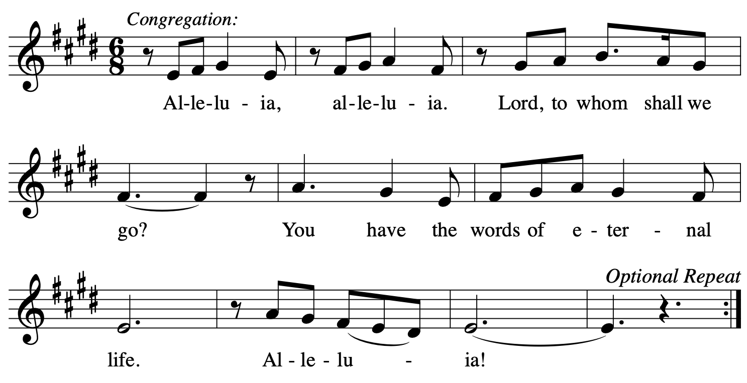
Gospel: Mark 8:27-38
The holy gospel according to Mark.
Glory to you, O Lord.
²⁷Jesus went on with his disciples to the villages of Caesarea Philippi; and on the way he asked his disciples, “Who do people say that I am?” ²⁸And they answered him, “John the Baptist; and others, Elijah; and still others, one of the prophets.” ²⁹He asked them, “But who do you say that I am?” Peter answered him, “You are the Messiah.” ³⁰And he sternly ordered them not to tell anyone about him.
³¹Then he began to teach them that the Son of Man must undergo great suffering, and be rejected by the elders, the chief priests, and the scribes, and be killed, and after three days rise again. ³²He said all this quite openly. And Peter took him aside and began to rebuke him. ³³But turning and looking at his disciples, he rebuked Peter and said, “Get behind me, Satan! For you are setting your mind not on divine things but on human things.”
³⁴He called the crowd with his disciples, and said to them, “If any want to become my followers, let them deny themselves and take up their cross and follow me. ³⁵For those who want to save their life will lose it, and those who lose their life for my sake, and for the sake of the gospel, will save it. ³⁶For what will it profit them to gain the whole world and forfeit their life? ³⁷Indeed, what can they give in return for their life? ³⁸Those who are ashamed of me and of my words in this adulterous and sinful generation, of them the Son of Man will also be ashamed when he comes in the glory of his Father with the holy angels.”
The gospel of the Lord.
Praise to you, O Christ.

Sermon Deacon Linda Bobbitt

Hymn of the Day All Hail the Power of Jesus' Name! (ELW 634)
This hymn was also sung 70 years ago at Advent during the Sept. 19, 1954 ordination service.

apostles’ Creed
I believe in God, the Father almighty,
creator of heaven and earth.
I believe in Jesus Christ, God’s only Son, our Lord,
who was conceived by the Holy Spirit,
born of the virgin Mary, suffered under Pontius Pilate,
was crucified, died, and was buried;
he descended to the dead.*
On the third day he rose again; he ascended into heaven,
he is seated at the right hand of the Father,
and he will come to judge the living and the dead.
I believe in the Holy Spirit,
the holy catholic church, the communion of saints,
the forgiveness of sins, the resurrection of the body,
and the life everlasting. Amen.

*Or, “he descended into hell,” another translation of this text in widespread use.

Prayers of Intercession
Each petition concludes: Hear us, O God.
The congregation responds: Your mercy is great.

Peace
The peace of Christ be with you always.
And also with you.
Meal
God feeds us with the presence of Jesus Christ.

Offering

OFFERTORY Advent Choir: “Now Thank We All Our God” (arr. Bob Burroughs)
“Now Thank We All Our God” was the closing hymn at Advent’s Organization Sunday in April 1954.

Offering Prayer
AM: Let us pray together:
Blessed are you, O God, source of every gift of your creation.
By these gifts and with our lives, help us to serve one another and all in need, through Jesus Christ, our Savior and Lord. Amen.

Great Thanksgiving

Dialogue
The Lord be with you.
And also with you.
Lift up your hearts.
We lift them to the Lord.
Let us give thanks to the Lord our God.
It is right to give God thanks and praise.

Preface
It is indeed right, our duty and our joy…we praise your name and join their unending hymn:

Holy, Holy, Holy
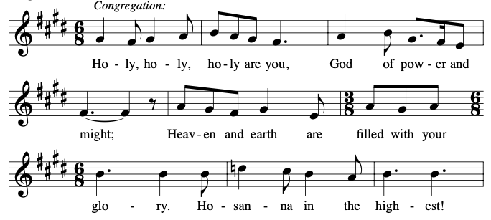
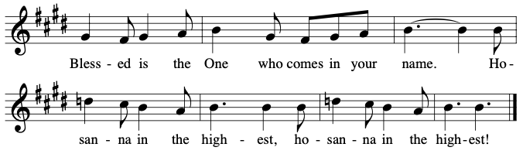

Thanksgiving at the Table

Lord’s Prayer
Our Father in heaven, hallowed be your name,
your kingdom come, your will be done,
on earth as in heaven.
Give us today our daily bread.
Forgive us our sins as we forgive those who sin against us.
Save us from the time of trial and deliver us from evil.
For the kingdom, the power, and the glory are yours,
now and forever. Amen.

Communion
Please come to the communion rail where you may kneel or stand. Gluten-free wafers are available upon request. Grape juice is also available in the center of each tray. If you would like to receive a blessing rather than the sacrament, fold your arms across your chest. All are welcome to commune at the Lord’s Table.

lamb of God
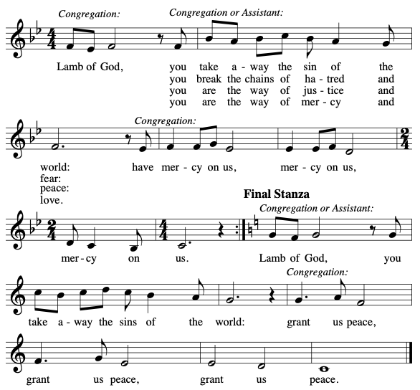

Communion Hymn Sing Out, Earth and Skies (W&P 126)

Communion Hymn Majesty (W&P 94)

Prayer after Communion
AM: Let us pray together:
Almighty God, we give you thanks that you have fed us with this heavenly food. In your grace and by your Spirit, help us to be what we celebrate, the body of Christ in the world. Send us out, renewed by this sacramental meal, to do the work you have given us to do: to witness for Christ, to love you with singleness of heart, and to serve you with clarity of purpose; through Jesus Christ, our Savior and Lord. Amen.

Sending
God blesses us and sends us in mission to the world.

Announcements

Blessing
God all mighty, God most merciful ☩ bless you, keep you, and give you peace.
Amen.

Sending Song Soli Deo Gloria (ELW 878)

Dismissal
Go in peace. Follow Jesus.
Thanks be to God.

POSTLUDE
From sundaysandseasons.com. Copyright © 2024 Augsburg Fortress. Gospel Acclamation, Holy, and Lamb of God from Now the Feast and Celebration by Marty Haugen Copyright 1990 by GIA Publications, Inc. All rights reserved. Permission to reprint, podcast, and / or stream the music in this service obtained from ONE LICENSE with license A-718094.

